Greenhouse Moisture Monitoring System: Proposal and Specifications

Brandon Tomlinson
Daniel Zundel
Heather Garnell

CprE588 Embedded Systems
Spring 2010

Iowa State University
Table of Contents
Table of Contents 2
Document Revision History 2
1 Scope 3
1.1 Purpose 3
2 Technical Requirements 4
2.1 General Description 4
2.2 System Complexity 4
2.3 Additional Complexity 5
3 Project Plan 6
3.1 Pictoral Specification Model 6
3.2 Specification Model 6
3.3 Architectural Model Refinement 6
3.4 Communication Model Refinement 6
4 Project Schedule 7
5 References 8

Document Revision History
NAME | date | description of change
Brandon Tomlinson | 4/13/10 | Updated to reflect design clarification

Scope

Purpose
This proposal contains a description of the semester project for CprE 588: Embedded Systems Group 03 to develop an environmental control system to monitor and control temperature and moisture levels in a greenhouse. Temperature and moisture levels are important considerations in the growth of most types of plants. As such, the purpose of this system is to monitor these two environmental factors and to actuate sprinkler and heating systems to control temperature and moisture levels.

Technical Requirements

General Description
Figure 1 depicts, at a high level, the expected functionality of the greenhouse environmental control system. One or more analog sensors will provide temperature readings from within the greenhouse, while one or more analog sensors will provide moisture readings from within the greenhouse to the embedded control system.
Each sensor will pass data through an analog-to-digital converter to a set of data processing functions. The data processing functions will correlate the temperature and moisture inputs with the user input settings to determine if the heater and/or sprinkler is needed to stabilize the environment.
A user interface will also be provided (notionally, an LCD display and keypad) to allow a user to input desired settings and to read back historical settings and actual sensor readings.
In order to test the functionality of the environmental control system, a testbench will be set up to read in dummy temperature and moisture readings from files, as well as to output the desired settings and historical sensor readings.
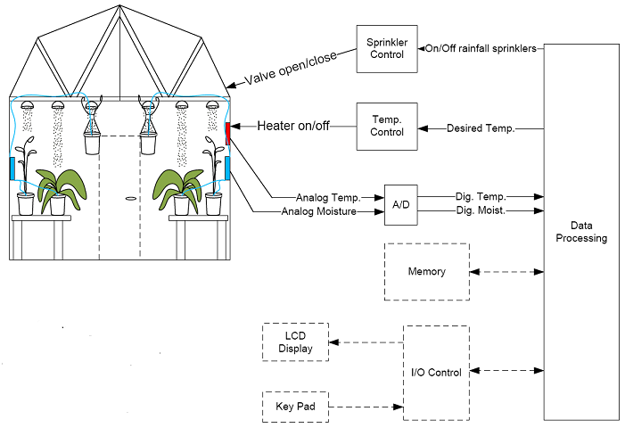
Figure 1, Top Level System View

System Complexity
The greenhouse monitoring system, per the requirements for the project, meets the level of complexity desired for the embedded system. The system contains:
- At least one sensor and/or data input function => temperature and moisture sensor
- A control loop => arranged to monitor sensor data and attempt to regulate moisture and temperature at a desired value.
- Data processing function => control loop logic
- Multiple processing elements => for A/D conversion of sensor data, data processing

Additional Complexity
As time permits, the team will incorporate additional levels of complexity into the embedded systems project. Items of additional complexity may include, but are not limited to:
- Inclusion of multiple temperature/moisture sensors
- “Smart System” that declares appropriate temperature and moisture settings based upon other than direct inputs
- Synchronization of sprinkler/heater functions with an internal system clock

Project Plan
The following sections detail the project execution plan and deliverables for CprE 588 Project Group 03.

Pictoral Specification Model
Figure 2 depicts the proposed specification model of the embedded environmental control system.
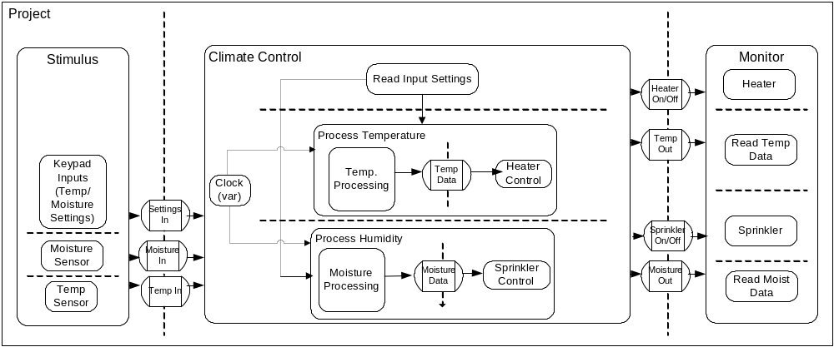
Figure 2. Initial Specification Model

Specification Model
SpecC will be used to develop the specification model of the environmental control system, according to the behaviors and channels as depicted in the above figure.

Architectural Model Refinement
The architectural refinement of the environmental control system will be performed using the System-on-Chip (SCE) tool. In conjunction with the architectural refinement, this tool will also be utilized to analyze performance metrics of the system and provide guidance in the selection of processing elements and making behavioral partitioning decisions.

Creative Component
TBD

Project Schedule
The project schedule for the embedded environmental control system is as follows:
Brandon | Post project proposal to WebCT | April 4, 2010
Heather | Add project information to website | April 4, 2010
Heather | C implementation - empty blocks designed | April 16, 2010
Heather | C implementation | April 19, 2010
Dan | C implementation | April 19, 2010
Brandon | Specification model in SpecC | April 25, 2010
Brandon | PSM from specification model | April 25, 2010
Dan | Specification model in SpecC | April 25, 2010
Brandon | Architecture refinement | April 30, 2010
Brandon | PSM from architecture model | May 2, 2010
All | Draft submission complete (website, lessons learned, code) | May 9, 2010
All | Final project due | May 14, 2010

References
- TBD

